Warm-up
Watch a piece of cartoon and say What do you feel? Make up a dialogue and use exclamatory sentences like It’s really splendid. It has a simple plot, but it’s touching.

Vocabulary
1. Divide the words in the list into three groups.
appear shoot cartoon character comic
come out play evil famous fictional film heroine latest laugh make write script popular coloured series successful
Noun | Adjective | Verb
cartoon

2. Complete the sentences with the words from activity 1. You may need to modify verbs.
- Mickey Mouse ________ in the first Disney ________ in 1928.
- Dallas was a very _______ American television ________ .
- In his ______ film, which will ______ out in August, he plays the role of an evil criminal.
- Both adults and children ______ at Donald who is probably the funniest and the most ______ duck in the world.
- Gone with the Wind was one of the most _______ movies ever made. It’s still _______ today. The ________ is a woman called Scarlett O’Hara.

Listening
Listen to the song from one of the best musical films “Moulin Rooszh”. The singers are Nicole Kidman and Ewan McGregor. Take the envelops on your desks, look through lines of the song and put them in the correct order while you are listening. You’ll listen to it only once.
The first line is:
Never knew I could feel like this…

Reading
1. Look at the pictures. Do you recognise these characters? Which ones do you know? Here are the names of the characters in English. Match the names with the characters.
Kermit (1957 - )
Bugs Bunny (1937 - )
James Bond (1953 - )
Batman (1939 - )
Asterix (1960s )

2. Read Fictional heroes never die and match the names in 1 with the paragraphs.

3. Answer the questions:
- What genres of films are typical for these fictional heroes?
- What are cartoon heroes?
- What are TV show’s heroes?
- What are heroes of action films?
- Who is Kermit?
- How long has Bugs Bunny been eating carrots in public?
- How long has Batman been saving Gotham City from evil?
- How many Muppet shows have people seen?
- How many cartoon films have Bugs Bunny and Asterix appeared in?
- How long has Kermit been singing and dancing on TV?

4. Find English equivalents for Russian ones in the text:
Художественный герой –
Как все мы –
Будут продолжать жить в будущем –
Появился примерно в 20 фильмах –
Преступники –
Самый популярный сериал –
Смеяться над кем-то/чем-то –
На публике –
Он остался неизменным –
Завоевать большую часть мира –
Первый полнометражный мультфильм –

Speaking
- Watch two pieces of adverts and say:
1. What are genres of these films?
2. Who are the actors?
3. What are the films about?
4. When will they come out?
5. What are the main heroes?
- Make up your own ads for your favourite films. Remember that you should mention the film’s date of coming – out, main heroes, what will the films be about, the actors of the film.
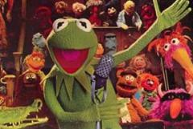
a
Real heroes are only human. They live and die like the rest of us. But fictional heroes are different. They began life many years ago and they will live on in fiction in the future. Here are some favourite twentieth-century fictional heroes.

b
The spy 007 has been working for the
1
British Secret Service since1953 when Ian Fleming first wrote about him in Casino Royale. Fleming is now dead, but the spy still lives on. The first film was Dr. No in 1962 and since then he’s appeared in over twenty films. The Cold War was finished and Bond’s enemies are not the Russians now, but there are still plenty of bad people out there! Columbia, the film producer, recently finished filming his latest adventures.
He first saved Gotham City from evil, with
2
the help of Robin, in a comic book in 1939 and has been fighting crime for over fifty years. The team has made three TV series, as well as films and novels. The most popular TV series was in the 1960s, and our hero has recently appeared in films. He will live on as long as there are criminals like Penguin, Catwoman and Joker in Gotham City.

The talking rabbit first asked “What’s up
3
Doc?” in 1037 and has been eating carrots in public ever since. He has appeared in comic books, newspaper strips and above all, hundreds of cartoon films. He will be popular for as long as people laugh at rabbits.

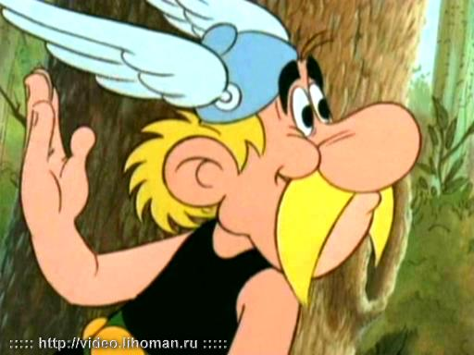
c


d
The green frog has been singing and
4
dancing on TV since 1957, although it was only in 1967 that he became famous with the Muppets. Since then, 235 million people in 100 countries have seen hundreds of Muppet shows. There have also been three films. Success has not changed him; he remains exactly the same colour.
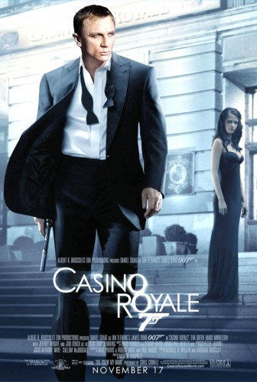
e
The Gaul, Asterix, has conquered most of
5
the world. The brave warrior and hid big friend Obelix have been delighted millions of comic-reading children and adults for more than 35 years. Plenty of people have seen the six full-length cartoon films set in Roman times. The cartoon books were written and drawn by French duo of Albert Uderzo and Rene Goscinny and were first published in 1960s.

